ADEKUNLE AJASIN UNIVERSITY AKUNGBA-AKOKO, ONDO STATE
DEPARTMENT: COMPUTER SCIENCE
FACULTY: COMPUTING

NAME: IKUEJAMOFO MARVELOUS OLUMUYIWA
MATRIC.NO: 220404072
LEVEL: 400
COURSE CODE: CSC 426
COURSE TITLE: Software Engineering

WEEKEND 3 ASSIGNMENT SOLUTION
QUESTION 1 - Google Form Link:
- Original Link:
https://docs.google.com/forms/d/e/1FAIpQLSddRMYhq0wZ0yb9npIt_g42Epz8F2ft54MAoMro-EgCLyu4nw/viewform?usp=publish-editor

- Shorten Link:
https://forms.gle/b7CipoxKYQjMyLKD7

QUESTION 2: Ishikawa analysis tool
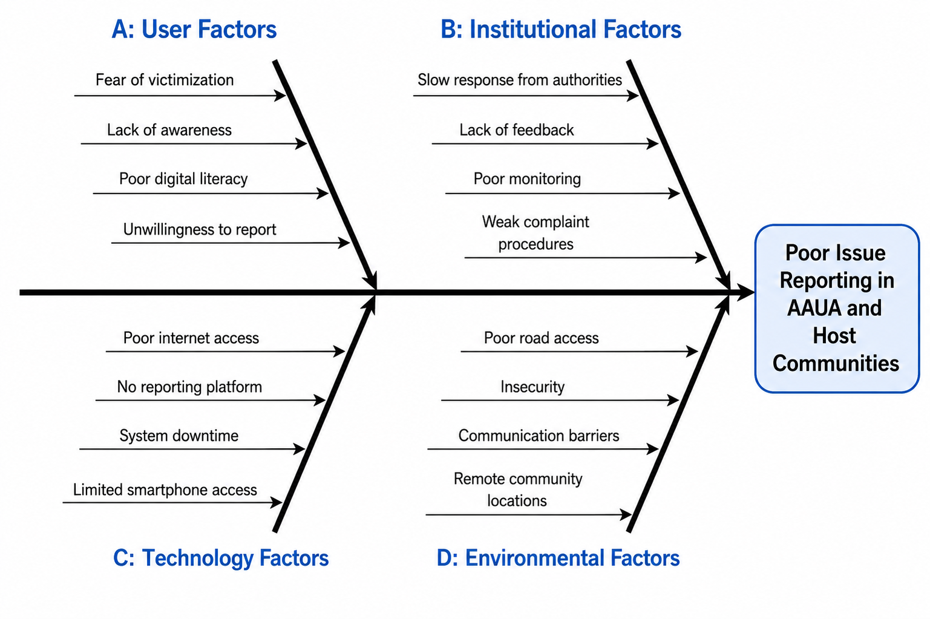
QUESTION 3: Mini web interface
Please check attached the IRO_app.html file
QUESTION 4: Use-case diagram
A. Actors
- Student
- Indigene
- Administrator
B. Use Cases
- Register
- Login
- Submit Report
- Upload Image
- Track Report
- View Feedback
- Manage Users
- Update Status
- Generate Report

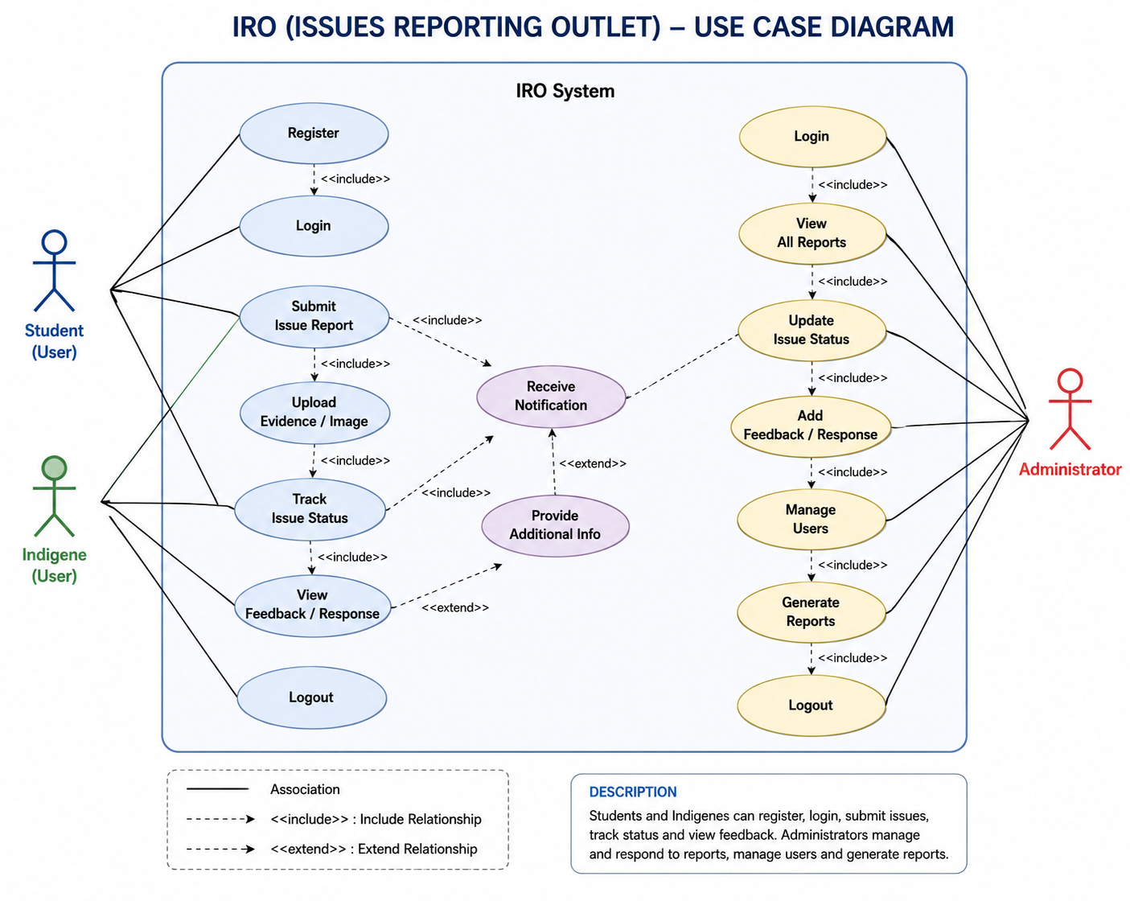

QUESTION 5: SRS (Software Requirement Specification) document
Please check attached the IRO_Software_Requirements_Specification.doc file

